Components:  - Three (3) × 2 m beam struts  - One (1) × 1 m beam strut  - Two (2) × end units with attached shackles and hooks  - Two (2) × lifting slings – 6m long  - Two (2) × crane forks  - One (1) × torque wrench  - One (1) × 30mm socket  - One (1) × breaker bar  - One (1) × 30mm spanner/podger  - Twenty-Four (24) × nuts/bolts & washers | 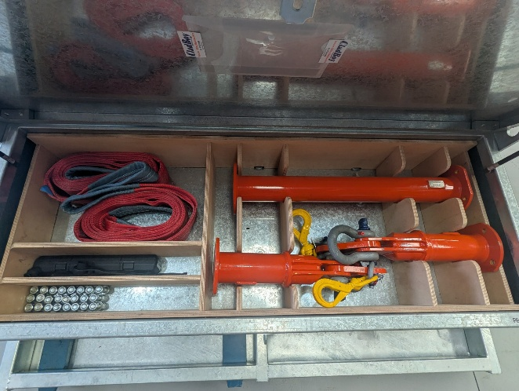

Step 1 – Remove Components from Stillage  - Remove the stillage locking bars  - Using a crane or telehandler, remove the crane forks from the stillage  Step 2 – Lay Out Beam Struts  - Lay beam struts end-to-end in correct configuration - use flats on each flange to prevent rolling | 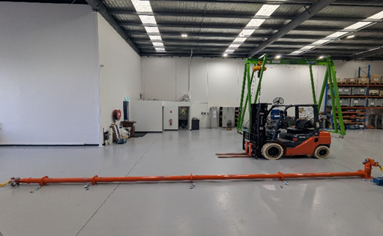

Step 3 – Bolt Beam Connections  - Ensure all flange faces are clean and free from debris  - Bolt all beam connections using supplied hardware  Bolting Requirements:  - Four (4) bolts per connection  - Tighten to 150 Nm using supplied torque wrench  - ❌ DO NOT OVER-TIGHTEN THE BOLTS | 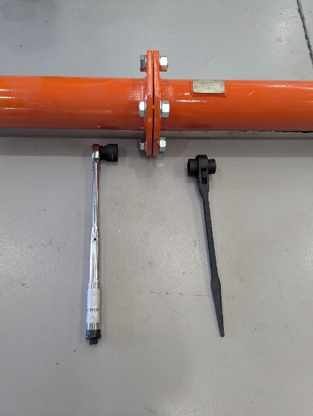

Step 4 – Attach Lifting Slings  - Attach one lifting sling through each large top shackle  - Ensure all shackle pins are securely tightened  Step 5 – Connect to Crane Hook  - Attach slings directly to the crane lifting hook  - ❌ Do not use additional slings or chains | 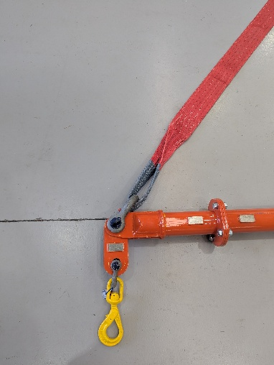

Step 6 – Attach Crane Forks  - Hoist beam clear of the ground  - Attach swivel hooks directly to the sprung arm on top of crane forks  - Control lines may be fitted to assist lift control  Step 7 – Positioning Into Panel Pack  - ⚠️ CRITICAL SAFETY STEP  - Ensure load is always balanced  - Fully insert crane forks  - Use supplied ladders to assist fork insertion  - ❌ Do not climb onto delivery vehicles | 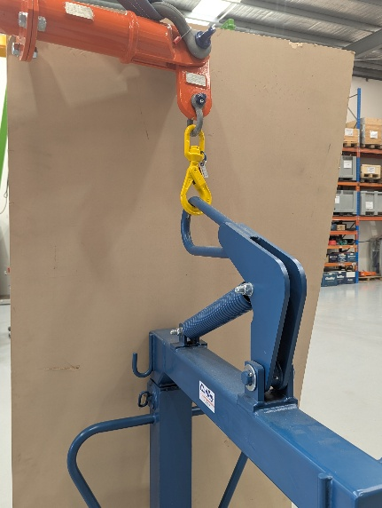

Disassembly and Storage  - Carefully disassemble the Pack Boy™  - Return all components to the storage stillage (see image in step 1 for storage)  - Secure components for carrier collection  Fastener Removal:  - ❌ Do not use the torque wrench  - Use supplied breaker bar only | Conditions of Hire and Use  ⚠️ MANDATORY CONDITION  - Any wilful or negligent damage, or loss of components, will result in charges for repair or replacement

